For the Foundation, Progress Includes Rounding Out the Team

Following the expansion of its Board of Directors, the Star of Hope has taken a bold step and recently hired its long-time consultant Carole Martin as Managing Director to oversee the day-to-day operations for the Foundation. Over the next several months Larry Sterrs, Executive Chairman, will transition from operations to focusing on Board-driven strategy. Following the completion of the transition, Martin will be the liaison with the Town of Vinalhaven as it pursues its downtown renovation plan, which the Star of Hope must understand fully before it moves ahead with any more significant plans for its real estate assets. Martin will be the contact person for all inquiries, business dealings and Foundation activities as the organization continues its work in Vinalhaven. She will also meet regularly with the expanded Board of Directors and help them finish their work developing a multi-year strategic plan.

Earlier this year, Sterrs announced that the Board had been expanded to include a number of subject matter experts who will help direct the artist endowed Foundation. Joining Sterrs on the board are:

- Mark Bessire – Judy & Leonard Lauder Director, Portland Museum of Art;
- Paul Bird – a Maine native and senior partner with the law firm Debevoise & Plimpton in New York City;
- Sharon Corwin – President & CEO, Terra Foundation for American Art in Chicago;
- Kris Davidson – Owner, Davidson Realty & Skål restaurant in Vinalhaven;
- Séan Alonzo Harris – Artist & professional commercial and fine art photographer and resident of Waterville;
- Emily Lane – Owner, Blue Lobster Consulting in Vinalhaven;
- Julia Trujillo Luengo – Director of Economic Development Coordination, State of Maine;
- Adam D. Weinberg – Alice Pratt Brown Director, Whitney Museum of American Art and
summer resident of Vinalhaven.

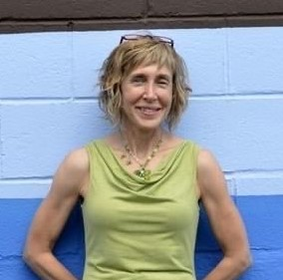

As an independent consultant, Carole Martin has the skills needed to analyze work environments through data review, review, discussion, and observation, then using the results to create strategies to propel organizations and communities forward. She has time and time again successfully overseen the forming, revitalizing, and managing complex collaborations & partnerships, including mergers & acquisitions, with special emphasis on strengthening connections while accomplishing important outcomes. Her work experience includes serving as director of labor relations and human resources for a large corporation, as well as holding senior leadership positions in a variety of for-profit and nonprofit settings. Her formal education includes a B.S., M.B.A., and advanced studies in the fields of negotiation and contract administration.

